Unit-I

Managerial Effectiveness

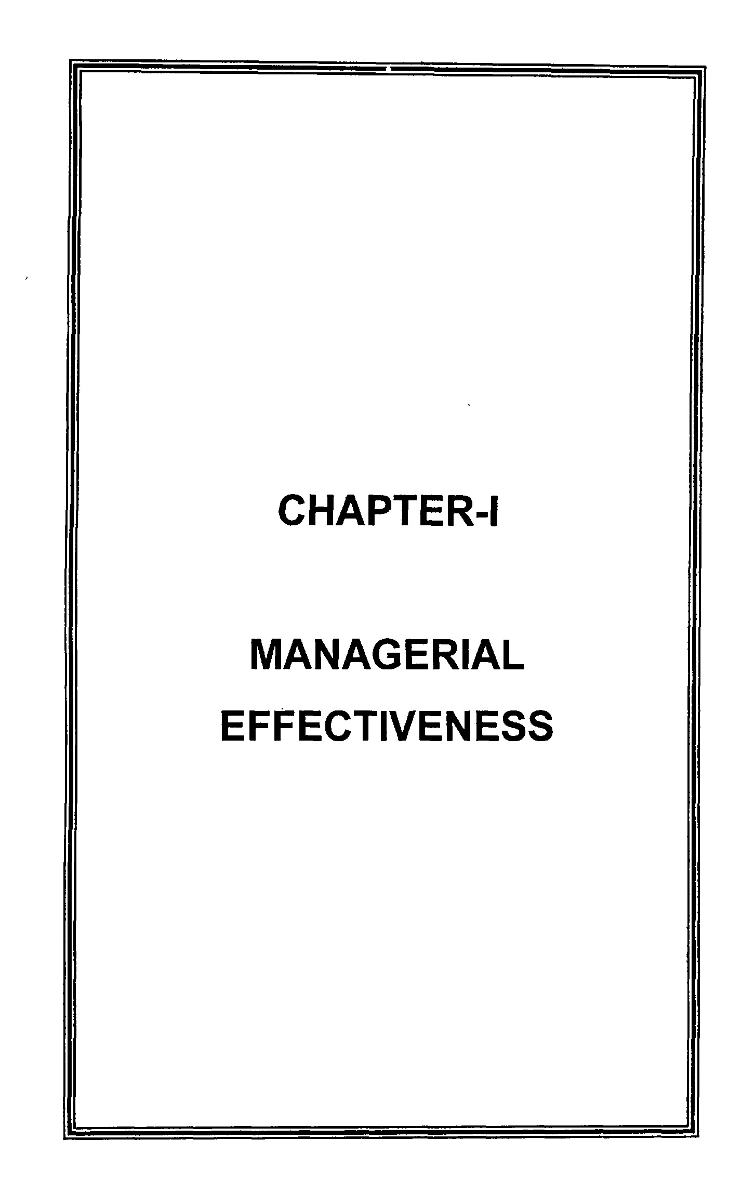
CHAPTER
-
I
MANAGERIA
L

1.1 INTRODUCTION

Management is basically concerned with ideas, things and people. In fact there are various definitions of management. But none has been universally accepted. Mary Parker Follett has suggested one simple definition which is very popular. According to her management is, "The art of getting things done through people." ^

The implication of this definition is very simple enough: - Managers strive to attain their goals by arranging for others to perform whatever tasks are necessary-not by performing the task themselves.

Every managerial job has effectiveness standards associated with it. They may not be written down or even known, but they are always there. These are the standards by which the performance of the manager in the job may be judged. Preparing and using such written standards has cured numerous management ills simply because the true reason for each managers existence is investigated, discussed and ultimately agreed on by the manager himself and by his superior. ^

People want to work and it is the manager's job to create situations where they can. Managers in industry are managers of the material resources of a country. They are solely responsible for combining resources in useful ways. Thus society benefits if the mangers are effective. It is the managers who can motivate and train their people to achieve the desired outputs of their jobs. But it is not only to their subordinates that can be useful. If they are effective in the sphere they can also help their superiors to achieve a higher degree of effectiveness. ^

1.2 MANAGERIAL EFFECTIVENESS

Management definition suggests that managers get things done by others. But no mention has been made so far about the responsibilities of managers to perform well. In this context P.P. Drucker'* has suggested that a managers performance can be measured in terms of two related concepts, efficiency and effectiveness. Efficiency means 'doing the right things. It may be mentioned that efficiency (or the ability to get the things done correctly) is basically are input- output concept. On the contrary, effectiveness is the ability to choose appropriate objectives or the appropriate means for achieving a given objective. Effective manager is one who selects the right thing to get done or the right methods for getting a particular thing done. For example a manager insists on producing only black and white camera when the demand for coloured camera is increasing very fast is supposed to be an in effective in manager, even if he achieves efficiency by producing black and white camera at the lowest possible cost or with maximum possible efficiency.

Needless to say the responsibilities of manager require performance that is both efficient and effective. As Drucker has argued, although efficiency is important, the key to the success of an organisation is effectiveness. The pertinent question is not how to do the things right but how to find the right things to do and to concentrate resources and efforts on them.

1.3 MEANING OF MANAGERIAL EFFECTIVENESS

Managerial effectiveness is the extent to which a manager achieves the output requirements of his position. This concept of inanagerial effectiveness is the central issue in management. It is the manager's job to be effective. It is his only job. Managerial rather than input, by what a manager achieves rather than by
what he does.

Effectiveness is not a quality a manager brings to a situation. To see it this way is nothing more than a return to the now discarded trait theory of leadership which suggested that more effective leaders has special qualities not possessed by less effective leaders. Effectiveness is best seen as something a manager produces from a situation by managing it appropriately. It represents output, not input. The manager must think in terms of performance, not personality. It is not so much what a manager does, but what he achieves. ^

Managerial effectiveness in the future attempts to give a few ideas about emerging trends that will affect effectiveness. Certainly it is quite clear that more and more workers and later managers will work from their homes. The normal office now is pedestrian. The two hours it takes to get to and from the office is often wasted time. We want managers to work smarter not harder. The technology exists for them to do this. The main reason they do not is overcoming their or their organisations natural resistance to change. ^

Managerial effectiveness- standards carried to their logical conclusion lead to management by objectives. This is nothing more than designing an organization around the output of managers jobs rather than the inputs. ^

1.4 IMPORTANCE OF MANAGERIAL EFFECTIVENESS

Managerial Effectiveness is central issue in the management. Every independent organisation wants to achieve goals effectively and efficiently. Managerial effectiveness is essential for and innovates new devices of motivation. Future oriented
leadership and motivational technique are utmost requirements of managerial effectiveness. Thinkers have suggested various methods of managerial effectiveness such as role playing, case study, MBO, Learning on Jobs, Business schemes, junior Boards, seminars, student sponsorship etc. They should be applied to different organisation according to their needs. Managerial effectiveness should be directly linked to organisation, philosophy, induction training, organisation development and business environment in the economy.

1.5 EFFECTIVENESS STANDARDS

Effectiveness standards is directly related to each other. Effectiveness standards are the general output requirements of a managerial position. Effectiveness standards for a position may remain unchanged year after year. Effectiveness standards define the function of the position. There are numerous standards on which the output of managerial positions may be based. Many are directly measurable using existing data generating devices such as accounting or reporting systems. ^

1.6 TYPES OF MANAGERIAL EFFECTIVENESS

•
Managerial effectiveness is not always clearly understood. Managers should learn to distinguish sharply between managerial effectiveness, apparent effectiveness and personal effectiveness.

1.6.1 Managerial effectiveness

Managerial effectiveness is the relationship between performance and task objectives and between achievement

1.7 MANAGERIAL EFFECTIVENFSS, EFFICIENCY AND PRODUCTIVITY

Effectiveness is measured by the value of output. The effect can be materialistic, spiritual or a combination of both. The measure of materialistic effect can be output. Spiritual effect which they do by providing service which is their output but intangible. Therefore the measure of effectiveness in service industry will be the value of their output not the input itself. ^^

Both effectiveness and efficiency are two sets of relationships of productivity which therefore can be improved upon by increasing the quantity of the output. The quantity and content of output can be augmented by increasing effort, working smarter, and utilisations of improved but relevant technology. The measure of effectiveness whether of an organisation or individual is performance, that is the attainment of the objective with a style. Performance is forward looking for one performs in the present and in the future, but not in the past. Therefore, when we talk of effectiveness, it relates to the present and the future. We maximise or optimise present productivity and survive to ensure future productivity. Effectiveness is not merely output. It means also the arraying of efforts in such away that the result is obtained at the deployment of the minimum amount of effort spread in a short span of time. The degree of effectiveness can, therefore, be defined by the amount of result obtained by the employment of a certain amount of effort. Improved results can also be had by an inoculation of effectiveness in the work system. ^^

1.8 OBJECTIVES OF MANAGERIAL EFFECTIVENESS

Objectives and effectiveness standards are directly

directly measurable using existing data generating devices such as accounting or reporting systems. In most firms some systems redesign is necessary to produce the data required. ^^

Managerial objectives may be drafted in one of the four ways.

Superior

Superior-^ ^Subordinate
Superior .•._,^^^^ ^^,,,^Superior Subordinate < Staff • Subordinate

Subordinate-^ •Superior
One method is for the superior to draft them for the subordinate. This is first seems the obvious v\/ay to do things and is still used by some. The second method involves the superior setting the objectives and then discussing them mXh the subordinate. The third method is widely used to establish objectives.

It consists of a third party, an internal or external consultant, who meets both privately and, jointly with the superior and subordinate and engineers their agreement to a set of objectives and subordinates. The fourth and recommended method is for the subordinate to draft a set of proposed objectives and over a series of several meetings, workout with his superior what his objectives should be. ^^

A sound objective must be measurable without this quality, its achievement cannot be established. It should be quantitative so that clear cut values can be placed on it. It should be an individual rather than a shared objective. It should be

- Not be so many as to avoid dealing with the essence of the job or so few as to make planning difficult

- Avoid over laps Avoid under laps Align vertically Align horizontally

1.11 HOW TO BECOME MORE EFFECTIVE

Once a manager has decided he wants to become effective, he should initially focus on how he could contribute more or at least more effectively than he is now doing. To be effective a manager must understand the existing organization philosophy and the direction in which it seems to be going. He should also know what makes for success in the company as a whole. But the decision to change organization philosophy can be made only at the top level. If the managers subordinates could take actions to improve his effectiveness, then presumably the manager can do the same for his superior. The manager is unlikely to do much in the way of changing his style, but he can make him more effective. The most effective way of making subordinates more effective is by giving them challenging responsibilities early in their career. A subordinate does not have to model his superior in order to become effective. ""^

Managers might well prepare a list of all the decisions facing them. This is not the usual list of things to do rather it contains each item on which a decision has to be made. The list should have the most pressing decision which is not necessarily the most important at the top. This list can be used as a guide to action. Any decision involving people has basic style elements are judgement and timeliness. Style is no substitute for
judgement. ^^

1.12 PRINCIPLES OF ORGANIZATIONAL EFFECTIVENESS

We are concerned not only with the outcome of a given leadership attempt but with the effectiveness of the organizational unit over a period of time. Rensis likert identifies three variables causal, intervening and end result which are useful in discussing effectiveness overtime. ^^

Causal variables are those factors that influence the course of developments within an organization and its results or accomplishments. These independent variables can be altered by the organization and its management; they are not beyond the control of the organization, like general business conditions. Leadership strategies skills and behaviour, management's decisions and the policies and structure of the organization are examples of causal variables. Leadership strategies skills and behavior and other causal variables affect the human resources or intervening variables in an organization. According to libert intervening variables represent the current condition of the internal state of the organisation. They are reflected in the commitment to objectives, motivation and morale of members and their skills in leadership communications, conflict resolution decision making and problem solving. The level or condition of the intervening variables is produced largely by the causal variables and in turn has influence upon the end result variables. Attempts by members of the organization to improve the intervening variables by endeavoring to alter these variables directly will be much less successful usually than efforts directed toward modifying then through altering the causal variables. Similarly efforts to improve the end-result variables by attempting to modify the intervening variables usually will be less effective than

1.13 LEADERSHIP FOR MANAGERIAL EFFECTIVENESS

Leadership makes a difference-management alone will not bring organisational success. Organisation of all types are discovering that something more is needed-leadership. If managers are to succeed, they must cultivate leadership skills. Among those skills are a commitment to quality and integrity, a willingness to innovate and sensitivity to the concerns of others. However the development of leadership skill is dependent upon the employing in situations giving the aspiring manager the freedom and responsibility to be an innovative leader early in the managerial career.

1.13.1 Leadership

Every modern society organisation, institution, country and the world require leaders to lead the people towards achievement of their common goals. Leadership provides direction, guidance restores confidence and makes the way easy for achieving the objectives. In business and industrial organisation managers play the role of leader and acquire leadership of subordinates, employees and workers working under them and are instrumental in guiding their efforts towards the achievement of organizational goals. Managers work under the framework of rules and regulations and employees can be controlled automatically. They also work still they need a leader who inspires them, guides them, directs them in their work. This is not done by rules and regulations. They are passive guides. Leader activates the people. He makes them work. Leadership influences behaviour of the people. Leadership has the ability to attract others and cause them to follow. ^^

Leadership acquires dominance and the followers accept his directives and control. Leadership provides direction and vision for future. Drucker says leadership requires aptitude and mea who are enough even without aptitude for leadership. Leadership also requires basic attitudes and nothing is as difficult to define, nothing as difficult to change, as basic attitudes. To talk of leadership as the unique key to spirit therefore only too often means neither action nor results. ^°

1.13.2 Traits of successful leaders

For many years the most common approach to the study of leadership concentrated on leadership traits suggesting that there were certain characteristics such as physical energy or friendliness that were essential for effective leadership. These inherent personal qualities like intelligence were felt to be transferable from one situation to another. Since all individuals did not have these qualities, only those who have them would be considered potential leaders. Consequently this approach seemed to question, the value of training individuals to assume leadership positions. It implied that if we could discover how to identify and measure these leadership qualities should be able to screen leaders from non leaders. Leadership training would then be helpful only to those with inherent leadership traits. ^^ As Engene E. Jennings concluded fifty years of study have failed to produce one personality trait or set of qualities that can be used to discriminate leaders and non leaders. ^^

The focus in the situational approach to leadership is on observed behaviour not on any hypothetical inborn or acquired ability or potential for leadership. The emphasis is on the behaviour of leaders and their group members and various situations. With this emphasis on behaviour and environment, more encouragement is given to the possibility of training individuals in adopting styles of leader behaviour to varying situations. Therefore it is believed that most people can increase their effectiveness in leadership roles through education, training and development. From observations of the

frequency of certain leader behaviour in numerous types of situations, theoretical models can be developed to help leaders make some predictions about the most appropriate leader behaviour for their present situation. For these reasons in this chapter we will talk in terms of leader behaviour rather than leadership traits, thus emphasizing the situational approach to leadership. ^^

1.13.3 leadership behaviours

The behavioral approach was designed to determine those behaviors that were associated with successful leadership. If leadership is to be successful the leader must get the job done. The necessary task performance behaviour refer to the things the leader does to ensure that the group reaches its objectives. The most common task performance factors were found to be fast work speed.

Good quality High quantity
Observation of the rules
Maintenance- oriented behaviours are those taken by the leader to ensure the social stability of the group, to develop and maintain harmonious work relationships and to maximize the satisfaction of group members. This leadership dimension is often known as a concern for people supportive leadership or consideration. ^'^

The successful leader knows that employees want to task part in making decisions that will have an impact on their work environment. However the successful leader also knows that the amount of participation that is possible or desirable varies with the situation. Thus the decision participation dimension of leadership behaviour can range from autocratic to democratic. Autocratic communicate them to group members. Democratic leaders solicit input from group members or even turn the decision• making role over to the group.

1.13.4 Managerial effectiveness vs leadership effectiveness

Leadership is a broader concept than management. Management is thought of as a special kind of leadership in which the accomplishment of organizational goals in paramount. Any time that you are attempting to influence the behaviour of some one else you are engaging in leadership. Therefore it is obvious that all your leadership behaviour is not directed toward accomplishing organizational goals. In fact many times when you are trying to influence someone else you are not even part of an organisation. ^^

Even within an organizational setting, managers may attempt to engage is leadership rather than management since they are trying to accomplish personal goals, not organizational ones. In attempting to achieve this goal, this executive may not be concerned with organizational goals at all but only with undermining the plans of the president and other executives who may be contenders for the job. An organizational environment which not only is inefficient but frustrating to the individuals who must cope with.

1.13.5 Role of managers as leaders

Manager who possess the quality of guiding and directing the subordinates to perform their jobs efficiently can be called business
leaders. A leader interprets the objective of the group and guide it
towards the achievement of these objective. According to louis.
A. Allen, "a leader is one who guides and directs other people".
^^ Thus, manager at all levels have to perform the functions of a
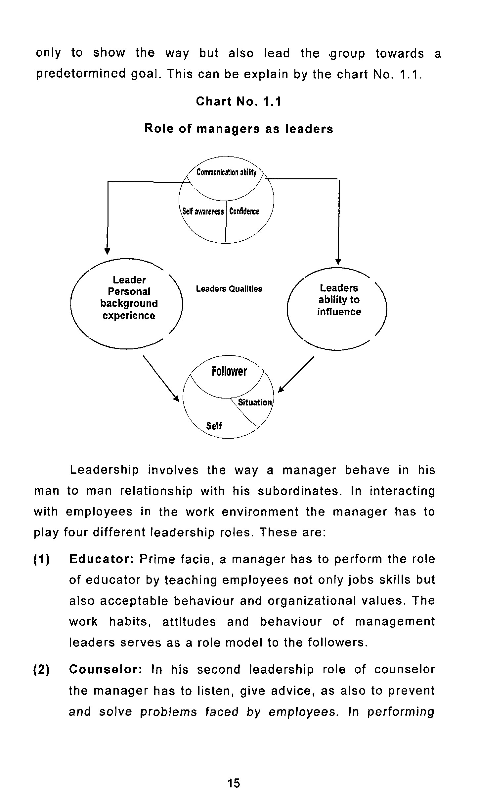
only

to

show

the

way

but

also

l
ead

the

group

towards

a
predetermined

goal.

This

can

be

explain

by

the

chart

No.

1.1.

Chart

No.

1.1

Role

of

managers

as

leaders

Leader
Personal
backgroun
d
experience

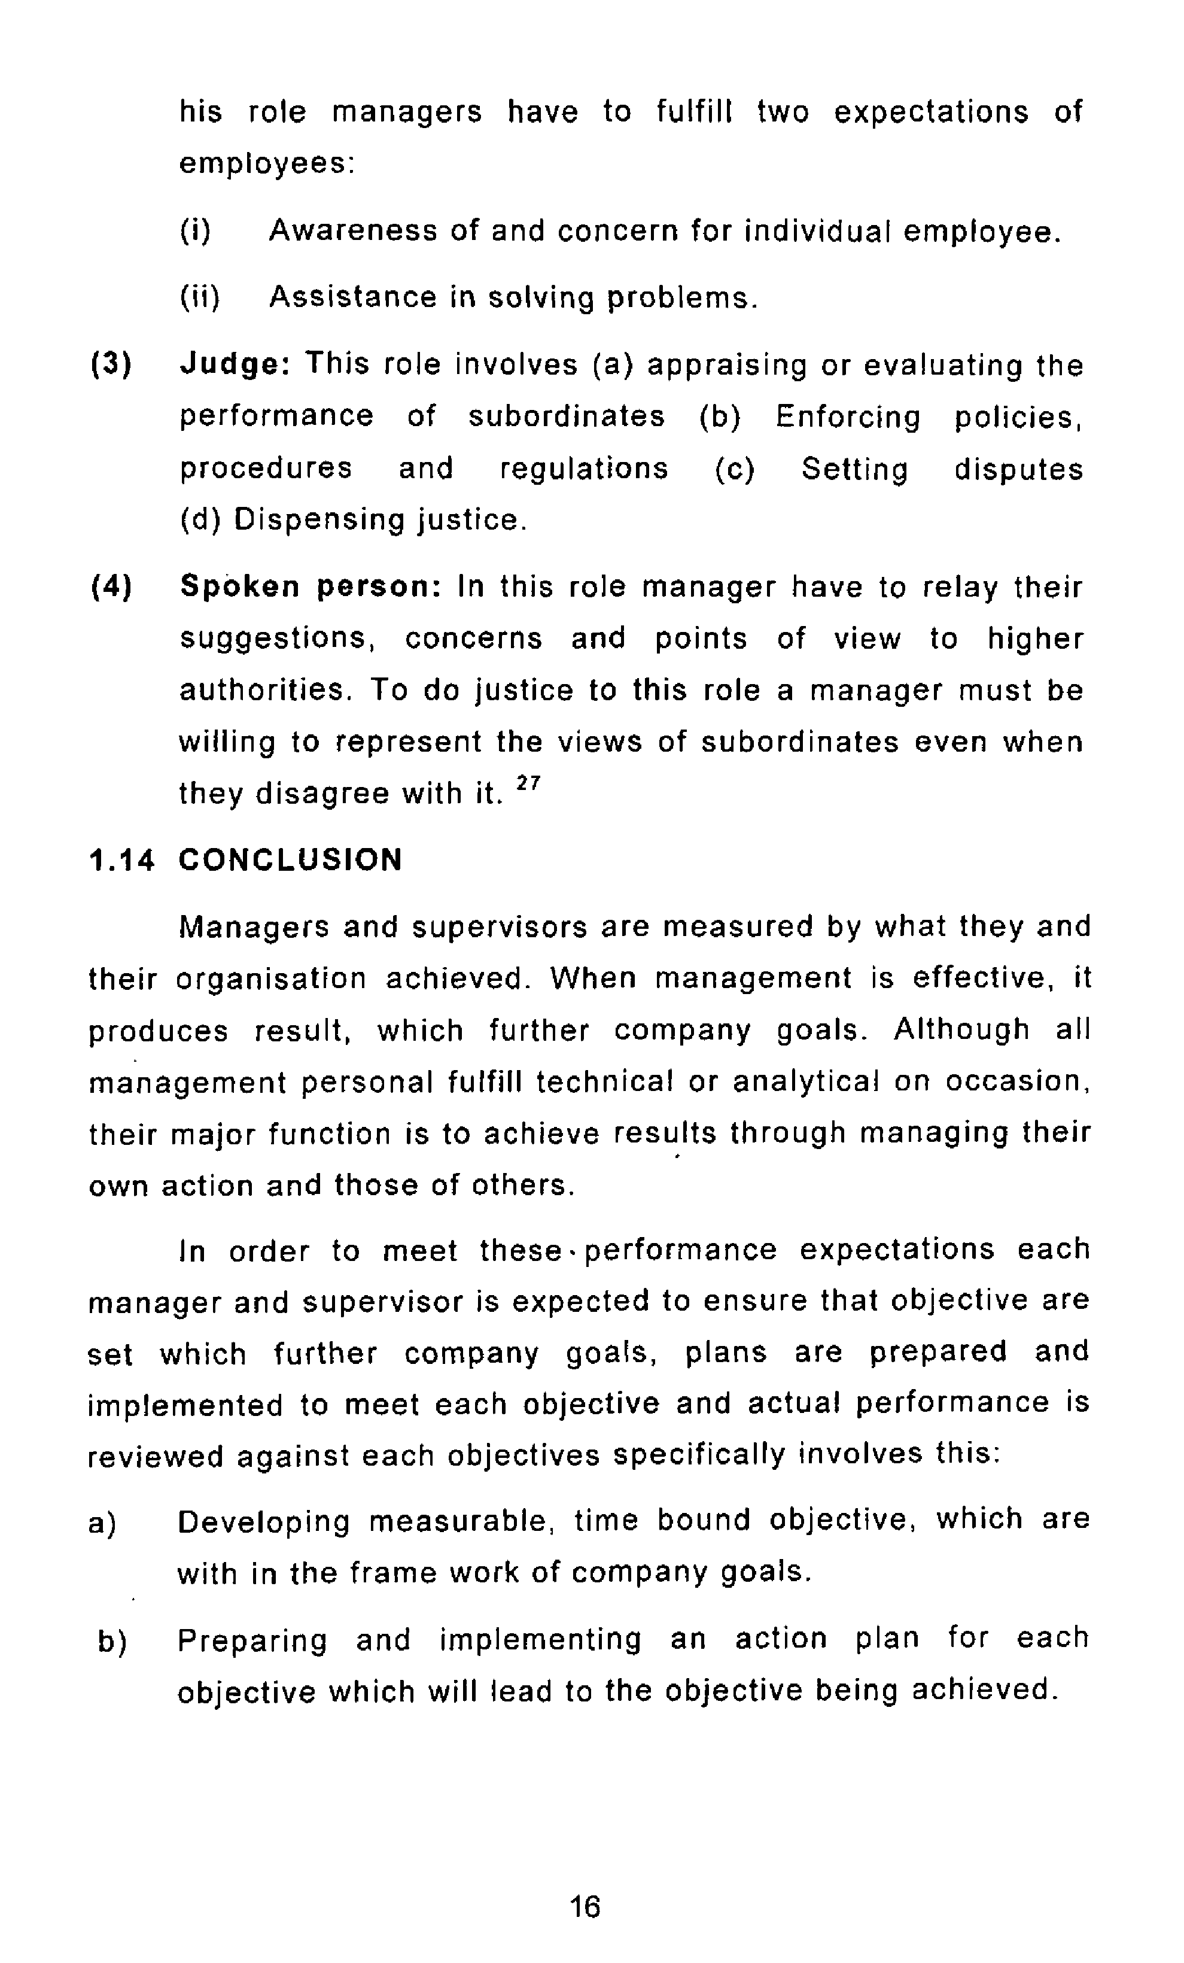
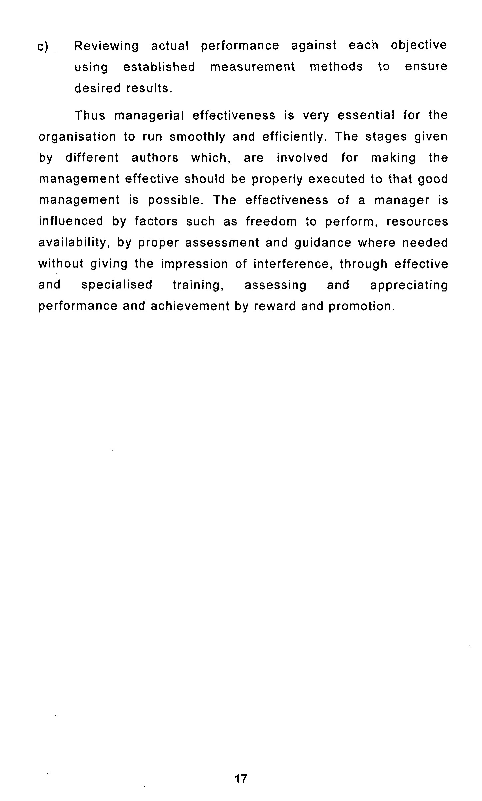
c)

Reviewing

actual

performance

against

each

objective
using

established

nneasurement

methods

to

ensure
desired

results.

Thus

managerial

effectiveness

is

very

essential

for

the
organisation

to

run

smoothly

and

efficiently.

The

stages

given by

different

authors

which,

are

involved

for

making

the
management

effective

should

be

properly

execute
d

to

that

good
management

is

possible.

The

effectiveness

of

a

manager

is
influenced

by

factors

such

as

freedom

to

perform,

resources
availability,

by

proper

assessment

and

guidance

where

needed
without

giving

the

i
mpression

of

interference,

through

effective
and

specialised

training,

assessing

and

appreciating
performance

and

achievement

by

reward

and

promotion.

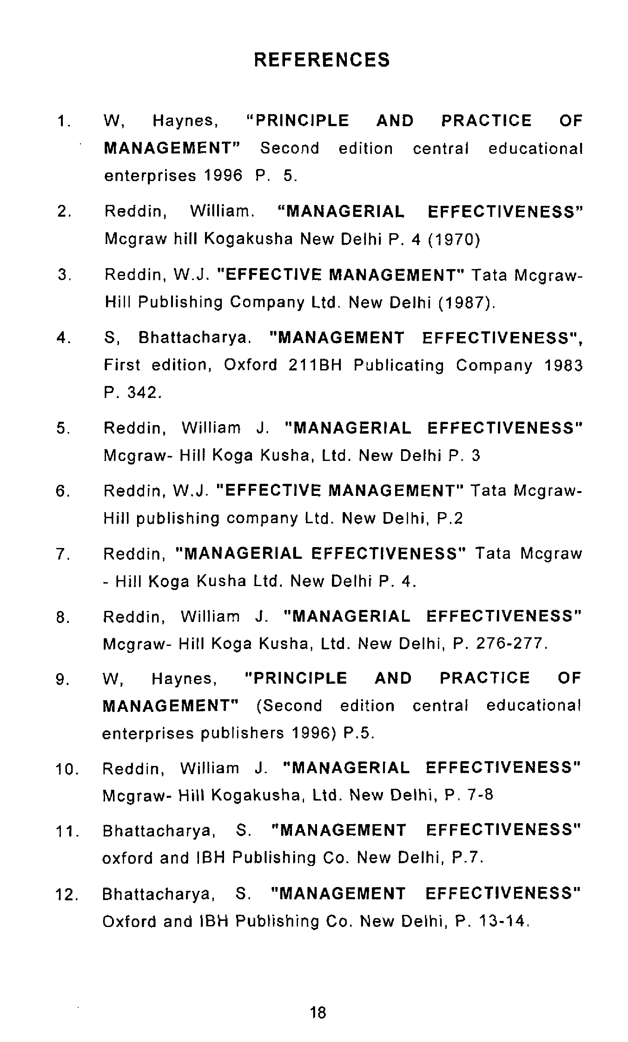
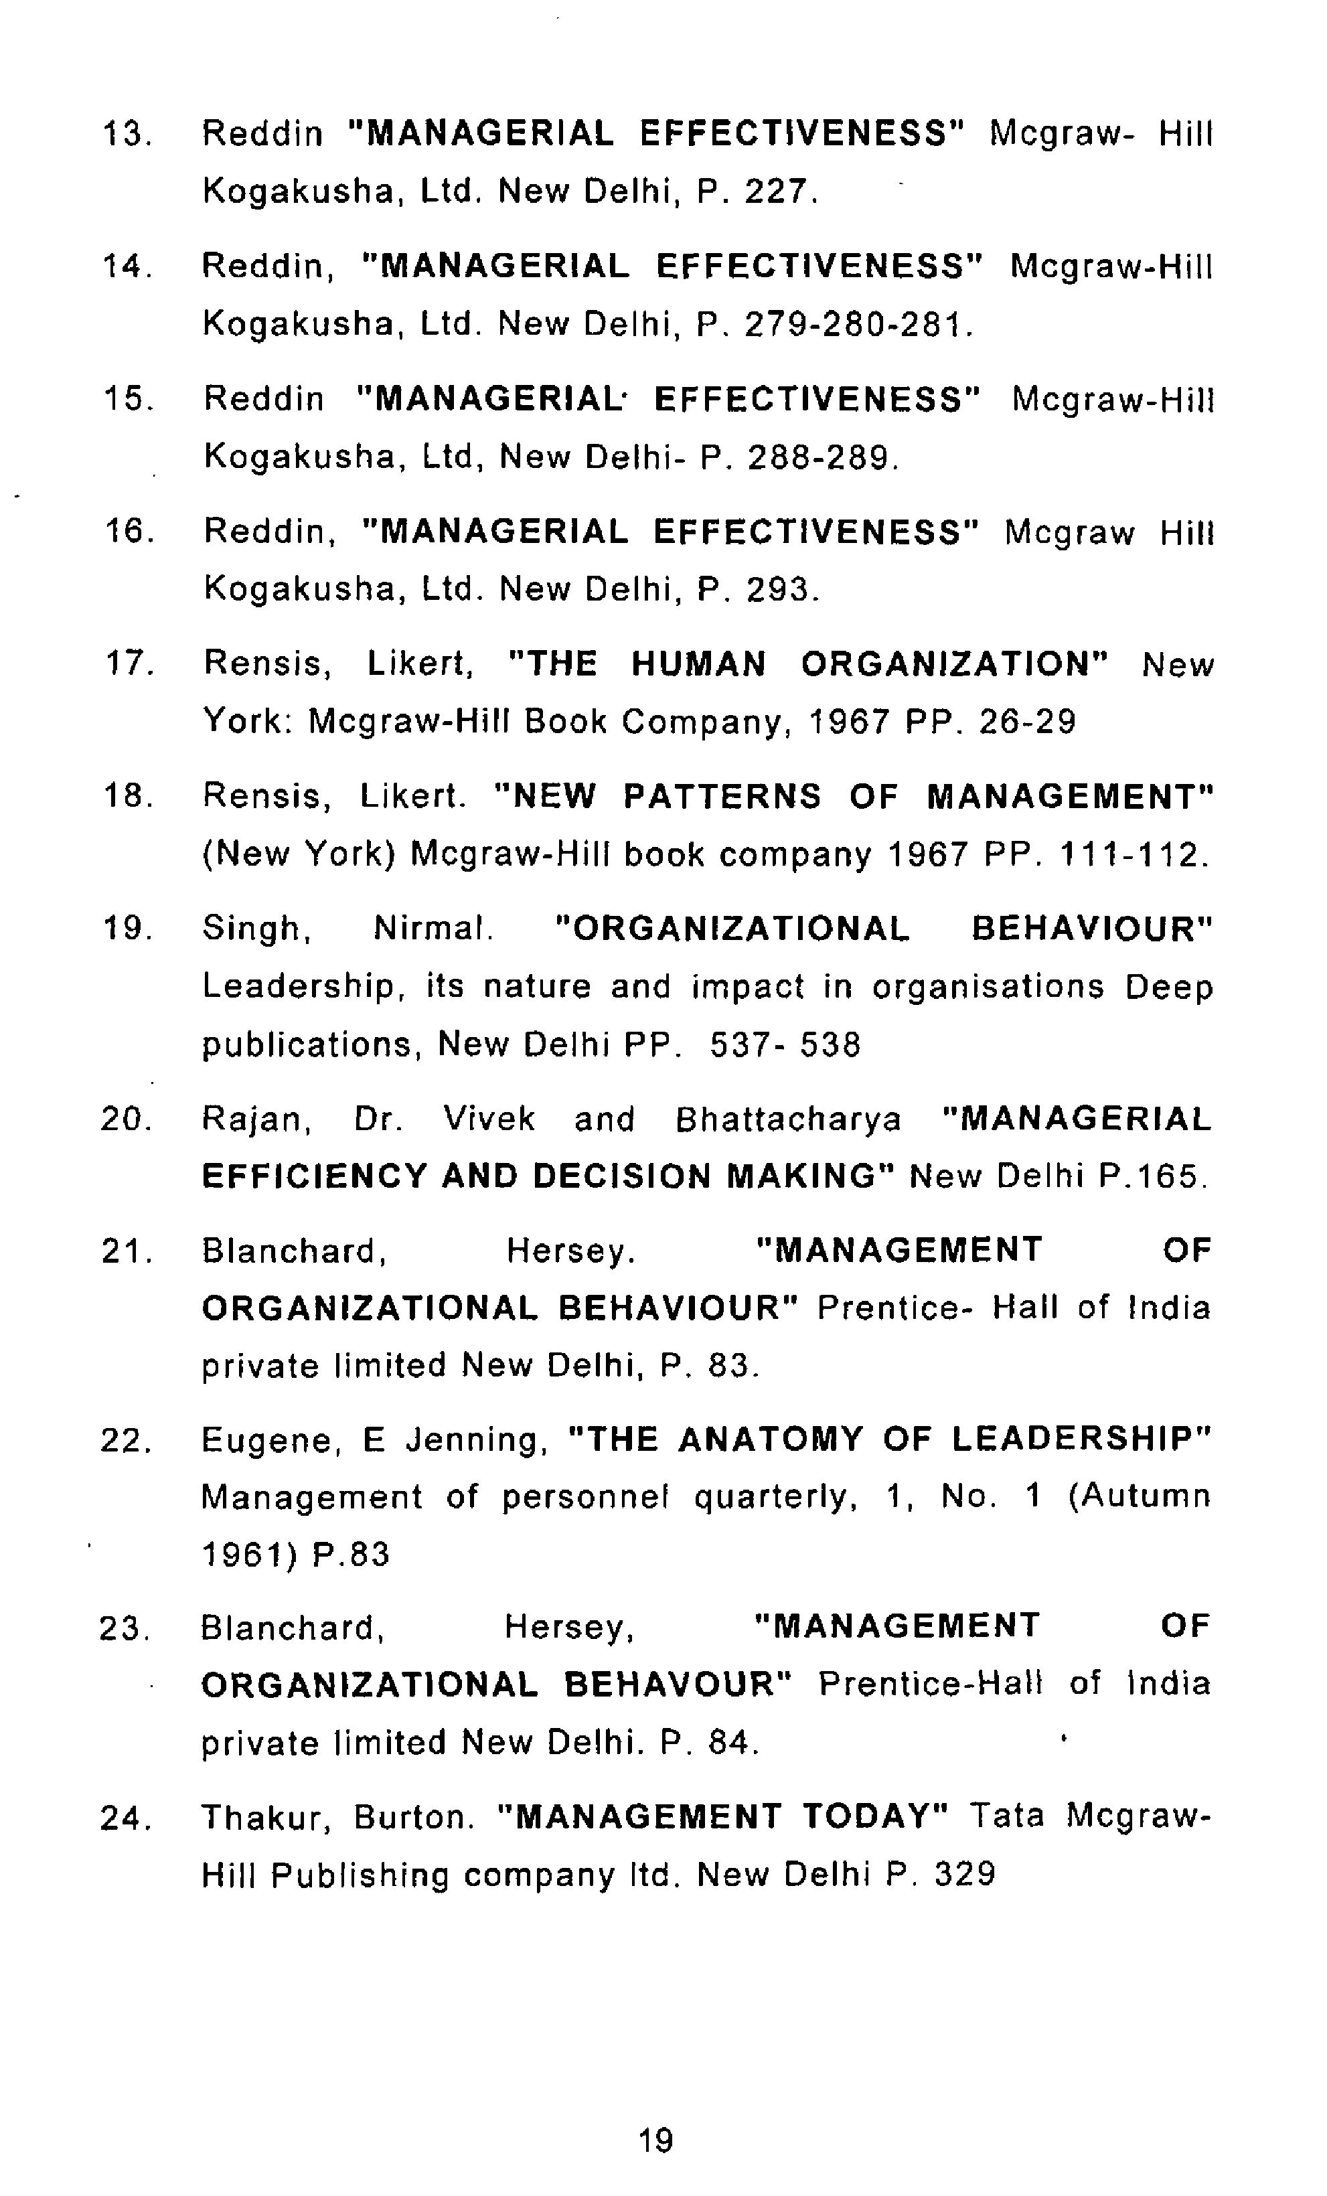

25.

Blanchard,

Mersey.

"MANAGEMENT

OF
ORGANIZATI
ONAL

BEHAVIOUR"

Prentice
-

Hall

of

India
Private

Limited

New

Delhi,

P

.106

26.

K.K.

Ahuja.

"PERSONNEL

MANAGEMENT"

Kalyani

Publisher

1994

P,

415.

27.

W,

Hazness,

"PRINCIPLE

AND

PRACTICE

OF
MANAGEMENT"

Second
(

edition

central

educational
enterprises

publisher

1996)

P.

5
-
6.

6
^^

61

